SYSTEM REQUIREMENT SPECIFICATIONS FOR GEO SPATIAL INFO TECH SOLUTIONS
PURPOSE OF THE SYSTEM
Local bodies are classified into Municipal Corporations, Municipalities of different grades depending upon the population and income of the Urban Local Body. These Urban Local Bodies have been constituted with the objective of discharging certain.
Obligatory functions like
- Supply of Drinking Water
- Providing Water connection to houses
- Sending water bills to houses
- Public Street Lighting
- Calculating and sending Electric Bills
- Maintaining sanitation and hygiene of public places
- Municipal Library maintenance.
- Calculate and sending Municipal tax and house taxes.
Local bodies like municipalities need collect different kind of taxes from the citizens. Every citizen need to pay Water Bills and Electricity Bills to the particular authorities. Actually a citizen want to pay his municipal tax means he should go to municipal office and collect the necessary bill, pay there only. Same as water and electricity bills also. This is not an easy job to get all these tax information in different authorities now days.
PROBLEMS IN THE EXISTING SYSTEM
- The existing system is a manual system. Here the employees needs to save the information in the form of excel sheets or Disk Drives.
- There is no sharing is possible if the data is in the form of paper or Disk drives.
- The manual system gives us very less security for saving data; some data may be lost due to mismanagement.
- It’s a limited system and fewer users friendly.
- Searching of particular information is very critical it takes lot of time.
- Gathering information of different sources is not an easy job, data will be mismanaged.
- Calculating different bills manually going to be as a process of mistake.
- There is no interface to provide various bills in the existing system.
- In the existing system citizen get the bills information manually, in various authorities like water board, electricity department, property tax department etc.

SOLUTION OF THESE PROBLEMS
The development of this new system contains the following activities, which try to automate the entire process keeping in the view of database integration approach.
- User Friendliness is provided in the application with various controls provided by system Rich User Interface.
- The system makes the overall project management much easier and flexible.
- It can be accessed over the Intranet.
- The employee information can be stored in centralized database which can be maintained by the system.
- This can give the good security for user information because data is not in client machine.
- Authentication is provided for this application only registered Users can access.
- There is no risk of data management at any level while the project development is under process.
- The automated system will provide to the employees for reliable services.
- The proposed system using web services, a web service can get the information from other sources also.
- There no burden of calculating water, electric, house tax bills in this system, by sending a request to the particular authority via web service we can get all the information regarding these issues.
STUDY OF THE SYSTEM
In the flexibility of uses the interface has been developed a graphics concepts in mind, associated through a browser interface. The GUI’s at the top level has been categorized as follows
- Administrative User Interface Design
- The Operational and Generic User Interface Design
The administrative user interface concentrates on the consistent information that is practically, part of the organizational activities and which needs proper authentication for the data collection. The Interface helps the administration with all the transactional states like data insertion, data deletion, and data updating along with executive data search capabilities.
The operational and generic user interface helps the users upon the system in transactions through the existing data and required services. The operational user interface also helps the ordinary users in managing their own information helps the ordinary users in managing their own information in a customized manner as per the assisted flexibilities.
Module Description
- Administrator
- Citizen’s
- Web Services
- Citizen’s Bill Information
- Search
- Reports
- Authentication

Administration
Administration is the main person of this system. He can have all the privileges to do anything in this system. Admin can get the information regarding citizen’s water bills, electric bills, and municipal taxes from various sources. For that administrator need to send a request for that particular authority throw web services.
Citizens
People who are living in that municipality area are called as citizens. Citizens need to pay water bill, electricity bill, property tax for a certain of intervals. By using this system interface citizen’s know their different bill amounts, pending bills, due dates etc.
Citizen Bill Information
The system interface is going to show the Bill information of different authorities. The bills mainly going to these types
- Water Bills
- Electricity Bills
- Property Taxes

These interface also shows the
- Pending Bills
- Penalties
- Due Dates

INPUTS AND OUTPUTS
The major inputs and outputs and major functions of the system are follows:
Inputs:
- Admin enter his user id and password for login.
- User enters his user id and password for login.
- Admin enter user id or date for track the user login information
- New users give his completed personnel, address and phone details for registration.
- Admin gives different kind of user information for search the user data.
- User gives his user id, hint question, answer for getting the forgotten password.
- User request for Municipal Bill.

Outputs:
- Admin can have his own home page.
- Users enter their own home page.
- The user defined data can store in the centralized database.
- Admin will get the login information of a particular user.
- The new user’s data will be stored in the centralized database.
- Admin get the search details of different criteria.
- User can get his forgot password.
- User can get Bill

SDLC METHDOLOGIES
This document play a vital role in the development of life cycle (SDLC) as it describes the complete requirement of the system. It means for use by developers and will be the basic during testing phase. Any changes made to the requirements in the future will have to go through formal change approval process.

SPIRAL MODEL was defined by Barry Boehm in his 1988 article, “A spiral Model of Software Development and Enhancement. This model was not the first model to discuss iterative development, but it was the first model to explain why the iteration models.
As originally envisioned, the iterations were typically 6 months to 2 years long. Each phase starts with a design goal and ends with a client reviewing the progress thus far. Analysis and engineering efforts are applied at each phase of the project, with an eye toward the end goal of the project.
The steps for Spiral Model can be generalized as follows:
- The new system requirements are defined in as much details as possible. This usually involves interviewing a number of users representing all the external or internal users and other aspects of the existing system.
- A preliminary design is created for the new system.
- A first prototype of the new system is constructed from the preliminary design. This is usually a scaled-down system, and represents an approximation of the characteristics of the final product.
- A second prototype is evolved by a fourfold procedure:
- Evaluating the first prototype in terms of its strengths, weakness, and risks.
- Defining the requirements of the second prototype.
- Planning an designing the second prototype.
- Constructing and testing the second prototype.
- At the customer option, the entire project can be aborted if the risk is deemed too great. Risk factors might involve development cost overruns, operating-cost miscalculation, or any other factor that could, in the customer’s judgment, result in a less-than-satisfactory final product.
- The existing prototype is evaluated in the same manner as was the previous prototype, and if necessary, another prototype is developed from it according to the fourfold procedure outlined above.
- The preceding steps are iterated until the customer is satisfied that the refined prototype represents the final product desired.
- The final system is constructed, based on the refined prototype.
- The final system is thoroughly evaluated and tested. Routine maintenance is carried on a continuing basis to prevent large scale failures and to minimize down time.

The following diagram shows how a spiral model acts like:

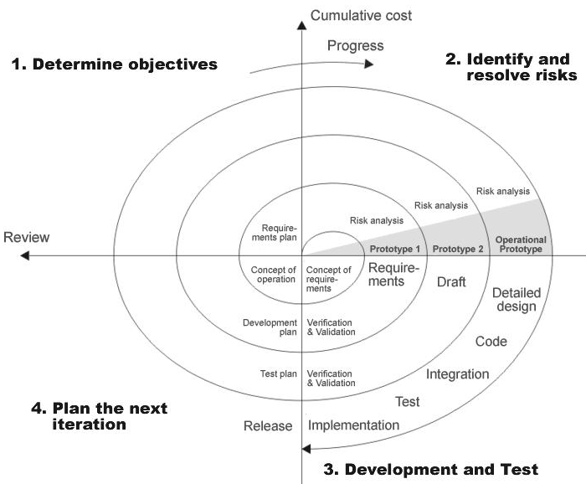

Fig 1.0-Spiral Model
ADVANTAGES:
- Estimates(i.e. budget, schedule etc .) become more relistic as work progresses, because important issues discoved earlier.
- It is more able to cope with the changes that are software development generally entails.
- Software engineers can get their hands in and start woring on the core of a project earlier.
INPUT DESIGN
Input design is a part of overall system design. The main objective during the input design as given below:
- To produce cost-effective method of input
- To achieve the highest possible level of accuracy.
- To ensure that the input is acceptable and understood by the user.
Input States:
The main input stages can be listed as below:
- Data recording
- Data transcription
- Data conversion
- Data verification
- Data control
- Data transmission
- Data validation
- Data correction
Input Types:
It is necessary to determine the various types of input. Inputs can be categorized as follows:
- External Inputs which are prime inputs for the system.
- Internal Inputs, which are user communications with the systems.
- Operational, which are computer department’s communications to the system?
- Interactive, which are inputs entered during a dialogue.
Input Media:
At this stage choice has to be made about the input media. To conclude about the input media consideration has to be given to:
- Type of Input
- Flexibility of Format
- Speed
- Accuracy
- Verification methods
- Rejection rates
- Ease of correction
- Storage and handling requirements
- Security
- Easy to use
- Portability
Keeping in view the above description of the input types and input media, it can be said that most of the inputs are of the form of internal and interactive. As input data is to be directly keyed in by the user, the keyboard can be considered to be the most suitable input device.
OUTPUT DESIGN:
Outputs from computer systems are required primarily to communicate the results of processing to users. They are also used to provide a permanent copy of the results for later consultation. The various types of outputs in general are:
- External Outputs, whose destination is outside the organization,.
- Internal Outputs whose destination is within organization and they are the
    - User’s main interface with the computer.
- Operational outputs whose use is purely within the computer department.
- Interface outputs, which involve the user in communicating directly with User Interface.

Output Definition:

The outputs should be defined in terms of the following points:
      - Type of the output
      - Content of the output
      - Format of the output
      - Location of the output
      - Frequency of the output
      - Volume of the output
      - Sequence of the output

It is not always desirable to print or display data as it is held on a computer. It should be decided as which form of the output is the most suitable.
For Example
- Will decimal points need to be inserted
- Should leading zeros be suppressed.

Output Media:
In the next stage it is to be decided that which medium is the most appropriate for the output. The main considerations when deciding about the output media are:
- The suitability for the device to the particular application.
- The need for a hard copy.
- The response time required.
- The location of the users
- The software and hardware available.

Keeping in view the above description the project is to have outputs mainly coming under the category of internal outputs. The main outputs desired according to the requirement specification are: The outputs were needed to be generated as a hot copy and as well as queries to be viewed on the screen. Keeping in view these outputs, the format for the output is taken from the outputs, which are currently being obtained after manual processing. The standard printer is to be used as output media for hard copies.

CONTEXT LEVEL DIAGRAM

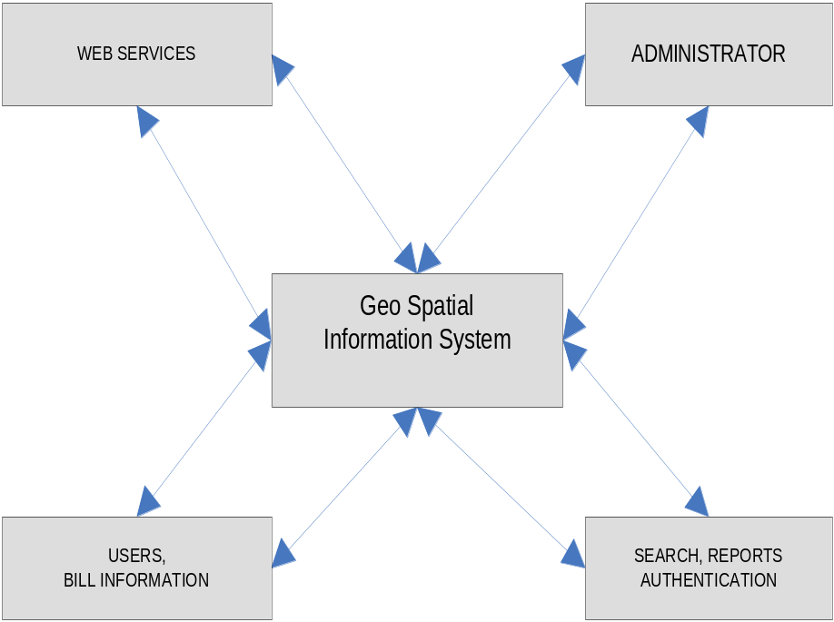

APPLICATION DEVELOPMENT:
N-Tier Applications:
N-Tier Applications can easily implement the concepts of Distributed Application Design and Architecture. The N-Tier Applications provide strategic benefits to Enterprise Solutions. While 2-tier, client-server can help us create quick and easy solutions and may be used for Rapid Prototyping, they can easily become a maintenance and security night mare
The N-tier Applications provide specific advantages that are vital to the business continuity of the enterprise. Typical features of a real life n-tier may include the following:
- Security
- Availability and Scalability
- Manageability
- Easy Maintenance
- Data Abstraction
The above mentioned points are some of the key design goals of a successful n-tier application that intends to provide a good Business Solution.
Definition:
Simply stated, an n-tier application helps us distribute the overall functionality into various tiers or layers:
- Presentation Layer
- Business Rules Layer
- Data Access Layer
- Database/Data Store
Each layer can be developed independently of the other provided that it adheres to the standards and communicates with the other layers as per the specifications.
This is the one of the biggest advantages of the n-tier application. Each layer can potentially treat the other layer as a ‘Block-Box’.
In other words, each layer does not care how other layer processes the data as long as it sends the right data in a correct format.

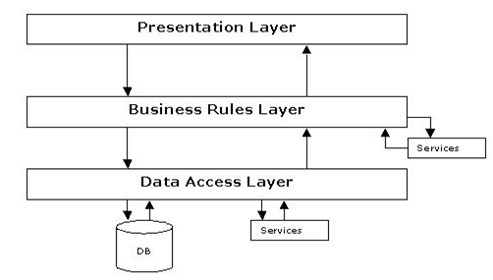
Fig 1.1-N-Tier Architecture

- The Presentation Layer:
Also called as the client layer comprises of components that are dedicated to presenting the data to the user. For example: Windows/Web Forms and buttons, edit boxes, Text boxes, labels, grids, etc.
- The Business Rules Layer:
This layer encapsulates the Business rules or the business logic of the encapsulations. To have a separate layer for business logic is of a great advantage. This is because any changes in Business Rules can be easily handled in this layer. As long as the interface between the layers remains the same, any changes to the functionality/processing logic in this layer can be made without impacting the others. A lot of client-server apps failed to implement successfully as changing the business logic was a painful process.
- The Data Access Layer:
This layer comprises of components that help in accessing the Database. If used in the right way, this layer provides a level of abstraction for the database structures. Simply put changes made to the database, tables, etc do not affect the rest of the application because of the Data Access layer. The different application layers send the data requests to this layer and receive the response from this layer.
- The Database Layer:
This layer comprises of the Database Components such as DB Files, Tables, Views, etc. The Actual database could be created using SQL Server, Oracle, Flat files, etc.
In an n-tier application, the entire application can be implemented in such a way that it is independent of the actual Database. For instance, you could change the Database Location with minimal changes to Data Access Layer. The rest of the Application should remain unaffected
PERFORMANCE REQUIREMENTS:
Performance is measured in terms of the output provided by the application. Requirement specification plays an important part in the analysis of a system. Only when the requirement specifications are properly given, it is possible to design a system, which will fit into required environment. It rests largely in the part of the users of the existing system to give the requirement specifications because they are the people who finally use the system. This is because the requirements have to be known during the initial stages so that the system can be designed according to those requirements. It is very difficult to change the system once it has been designed and on the other hand designing a system, which does not cater to the requirements of the user, is of no use.

The requirement specification for any system can be broadly stated as given below:
- The system should be able to interface with the existing system
- The system should be accurate
- The system should be better than the existing system
The existing system is completely dependent on the user to perform all the duties.
FEASIBILITY REPORT:
Preliminary investigation examine project feasibility, the likelihood the system will be useful to the organization. The main objective of the feasibility study is to test the Technical, Operational and Economical feasibility for adding new modules and debugging old running system. All system is feasible if they are unlimited resources and infinite time. There are aspects in the feasibility study portion of the preliminary investigation:
- Technical Feasibility
- Operation Feasibility
- Economical Feasibility
Technical Feasibility
The technical issue usually raised during the feasibility stage of the investigation includes the following:
- Does the necessary technology exist to do what is suggested?
- Do the proposed equipments have the technical capacity to hold the data required to use the new system?
- Will the proposed system provide adequate response to inquiries, regardless of the number or location of users?
- Can the system be upgraded if developed?
- Are there technical guarantees of accuracy, reliability, ease of access and data security?
Earlier no system existed to cater to the needs of ‘Secure Infrastructure Implementation System’. The current system developed is technically feasible. It is a web based user interface for audit workflow at NIC-CSD. Thus it provides an easy access to the users. The database’s purpose is to create, establish and maintain a workflow among various entities in order to facilitate all concerned users in their various capacities or roles. Permission to the users would be granted based on the roles specified. Therefore, it provides the technical guarantee of accuracy, reliability and security. The software and hard requirements for the development of this project are not many and are already available in-house at NIC or are available as free as open source. The work for the project is done with the current equipment and existing software technology. Necessary bandwidth exists for providing a fast feedback to the users irrespective of the number of users using the system.
Operational Feasibility
Proposed projects are beneficial only if they can be turned out into information system. That will meet the organization’s operating requirements. Operational feasibility aspects of the project are to be taken as an important part of the project implementation. Some of the important issues raised are to test the operational feasibility of a project includes the following: -
- Is there sufficient support for the management from the users?
- Will the system be used and work properly if it is being developed and implemented?
- Will there be any resistance from the user that will undermine the possible application benefits?
This system is targeted to be in accordance with the above-mentioned issues. Beforehand, the management issues and user requirements have been taken into consideration. So there is no question of resistance from the users that can undermine the possible application benefits.
The well-planned design would ensure the optimal utilization of the computer resources and would help in the improvement of performance status.

Economic Feasibility
A system can be developed technically and that will be used if installed must still be a good investment for the organization. In the economical feasibility, the development cost in creating the system is evaluated against the ultimate benefit derived from the new systems. Financial benefits must equal or exceed the costs. The system is economically feasible. It does not require any addition hardware or software. Since the interface for this system is developed using the existing resources and technologies available at NIC, There is nominal expenditure and economical feasibility for certain.

